
Business Journalism Project

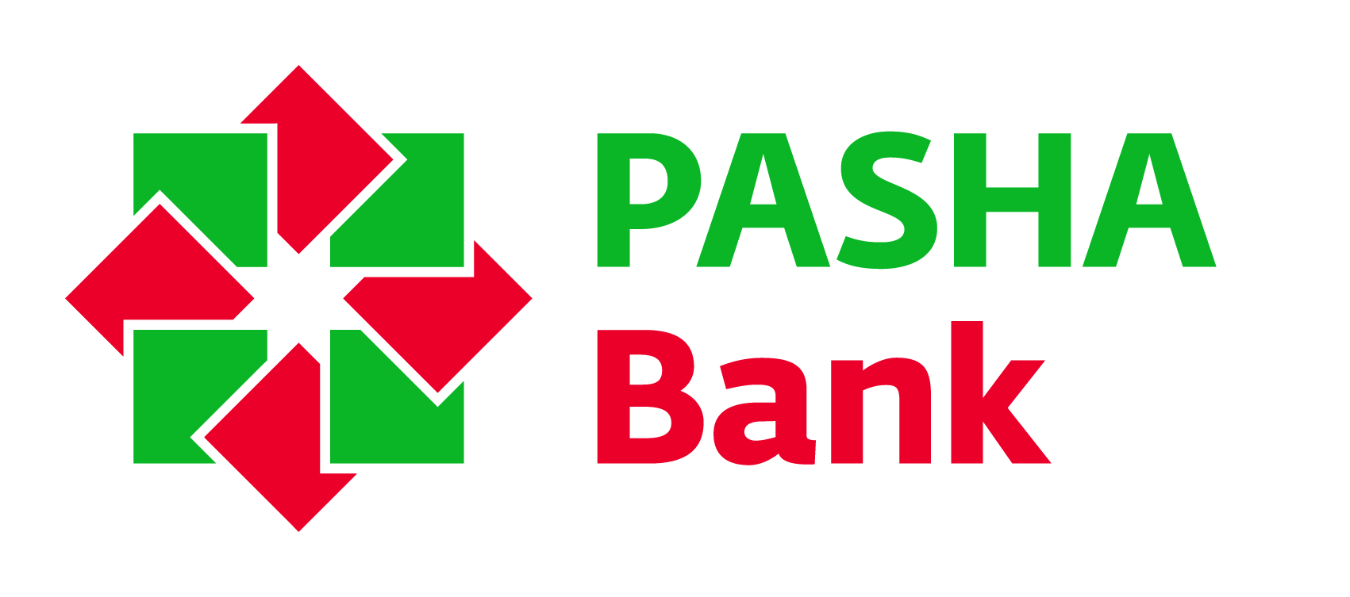

The British Council and PASHA Bank with the support of the United Kingdom’s Thomson Foundation organization is pleased to announce the next special training programme for journalists.

The project is aimed at helping the national media (broadcast, print and online media) strengthen their professional competencies and skills through a specifically designed comprehensive training programme which will address participants’ journalistic skills.

10 participants will be selected to take part in the training sessions which will be held in Baku starting from November 2016. The most active participants with full attendance at the training sessions will attend Thomson Foundation Study Tour programme in UK in March, 2017.

We encourage journalists from all regions of Azerbaijan to apply for participation at the training.

Note: Previous participants of Business Journalism project are not eligible to apply.

The programme will focus on enhancing the following journalistic competencies and skills:
- different styles of story writing
- features writing skills
- news reporting
- news writing
- interviewing techniques and practices

The training will be based on the following themes:
- Ethics, balanced and fair reporting
- Economics journalism and online media
- Business journalism

Eligible participants must:
- Have at least 2 years of working experience in journalism
- be working for national broadcast, print, electronic periodical or online media;
- be available for the above-mentioned training courses for an extended period of time which includes:

- 3 training sessions (5 days each session) in Baku in November 2016, January and February 2017
- Study Tour in the UK in March 2017

Note: Participation at all the above mentioned training sessions is mandatory.

Selection process will include the following stages:
- Application form and essays
- Interviews with the shortlisted candidates and selection for the local training sessions
- Selection for the UK Study Tour (after local training sessions).

All interested applicants should download an application form from the British Council website www.britishcouncil.az and email to enquiries@britishcouncil.az together with CV not later than 30 September 2016.

Shortlisted candidates will be contacted for an interview.
For further information please contact:
Nigar Nasrullayeva
Education Officer
British Council Azerbaijan
T + 994 12 497 15 93
+ 994 12 497 20 13
F + 994 12 498 92 36
www.britishcouncil.az

British Council is committed to policy of equal opportunity and the promotion of diversity.

